ANNEX B
2012 NJC H2 Maths Preliminary Examination Paper 1

Qn/No | Topic Set | Answers
1 | System of Linear Equations | 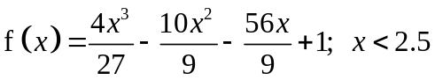
2 | Vectors | (ii) 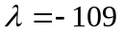  Since P is on BA produced,  for a negative value of k.
3 | Maclaurin Series | 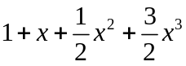  (a) 13  (b) 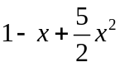
4 | Differential Equation | (ii) 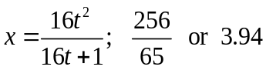  (iii) The particular solution of the DE suggests that the amount of bacteria in the Petri dish will grow indefinitely as time passes.
5 | Differentiation and Application of Integration involving Parametric Equations | (ii) b = −4.5
6 | Vectors | (a) 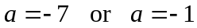  (b) 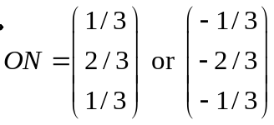  (c) 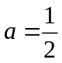,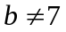
7 | Arithmetic and Geometric Progressions | (a)(ii) 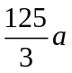  (b)(i) 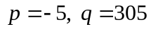  (ii) 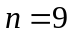
8 | Complex Numbers | 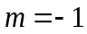  (i) 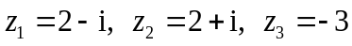  (iii) Since 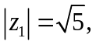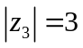, 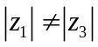.  The locus of complex numbers satisfying the equation 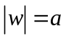, for some positive constant a, will not pass through all the points representing the complex numbers 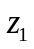, 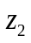 and 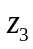.
9 | Sequences and Series/ Method of Difference/ Mathematical Induction | (ii) 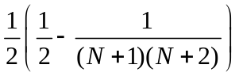  (iv) 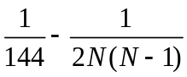
10 | Curve Sketching/ Graph Transformations | (a)  (i) Vertical asymptotes: or  Horizontal asymptote: 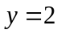  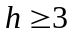
11 | Functions/ Inequalities | (i) 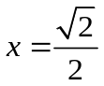  (ii) k = (1 − e^{9/8})/2 or −1.04  (iii) 